Lab no 03 tasks

Task no 1

The variable has the limited range that it can take values within it. The number used is out of that range.

Task no 2

#include<stdio.h>

main(){

int num1;

int num2;

int num3;

int max;

printf("enter num1: ");

scanf("%d", &num1);

printf("enter num2: ");

scanf("%d", &num2);

printf("enter num3: ");

scanf("%d", &num3);

if(num1>num2){

max = num1;

}

else{

max = num2;

}

if(num3>max){

max = num3;

}

else{

max = max; -

}

printf("max is : %d", max);

}

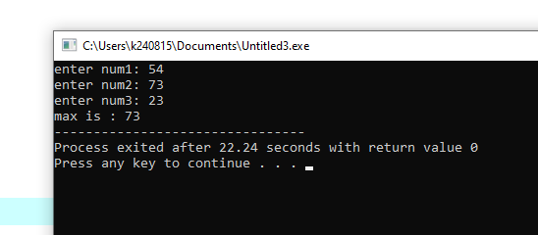

Task no 3

#include<stdio.h>

main(){

int num1;

printf("enter num: ");

scanf("%d", &num1);

if((num1%2==0)){

printf("this is an even num");

}

else{

printf("this is an odd num");

}

}

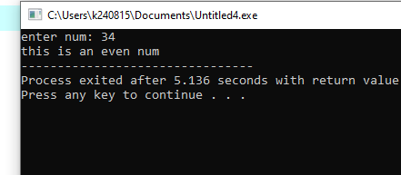

Task no 4

#include<stdio.h>

main(){

float amountinrs;

float convrate;

float amountin$;

printf("enter amount in rs: ");

scanf("%f",&amountinrs);

printf("enter convrate: ");

scanf("%f",&convrate);

amountin$ = (amountinrs \* convrate);

printf("Amount in $: %f", amountin$);

}

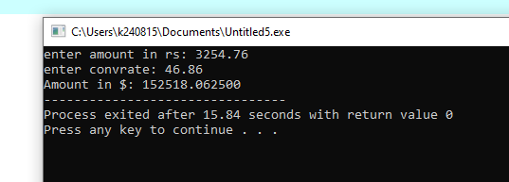

Task no 5

#include<stdio.h>

main(){

float Oamount;

float finalamount;

float dis;

printf("enter original amount : ");

scanf("%f",&Oamount);

if(Oamount<100){

printf("discount not available ");

}

else if(Oamount>=100 & Oamount<1000){

dis = 5;

}

else if(Oamount>=1000 & Oamount<10000){

dis = 10;

}

else if(Oamount>=10000 & Oamount<15000){

dis = 15;

}

else if(Oamount>=15000 & Oamount<30000){

dis = 20;

}

else if(Oamount>=30000 & Oamount<40000){

dis = 25;

}

else if(Oamount>=40000){

dis = 30;

}

finalamount = Oamount\*(1-(dis/100));

printf("final price: %.2f", finalamount);

}

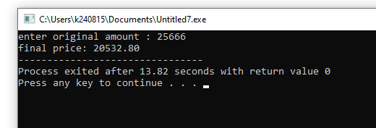

Task no 6

#include<stdio.h>

main(){

float height;

float radius;

float volume;

printf("height: ");

scanf("%f",&height);

printf("radius: ");

scanf("%f",&radius);

volume = (3.14159\*radius\*radius\*height);

printf("volume is : %.2f", volume);

}

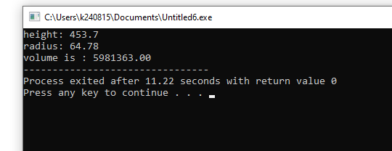

Github task

create branch;

